COURSE: HCI & CG
PROJECT REPORT

Introduction

2.1 Background
Student societies are vital for extracurricular growth in university life. The STEM Society at FJWU organizes various seminars, workshops, and competitions. However, managing hundreds of students, organizing events, and conducting fair elections manually was proving to be error-prone, time-consuming, and inefficient.

2.2 Problem Statement
The manual system faced several critical issues:
- Lack of Centralized Management: Data regarding students, events, and chapters was scattered across papers and spreadsheets.
- Manual Processes: Registration and nomination forms were physical, leading to data entry errors and loss of documents.
- Communication Gaps: Students often missed updates regarding events due to the lack of a central notification hub.
- Profile Inflexibility: Once registered, students had no digital way to update their academic progress (semester change) or personal details.
- Security Risks: Manual handling of student data posed privacy and security risks.

2.3 Proposed Solution
We developed a dynamic website using PHP and MySQL that serves as a single point of access. The system automates ID generation ,ensures secure logins with "Remember Me" functionality, allows real-time profile editing, and provides a transparent election system.

3. System Modules & Detailed Features
The project is divided into three major modules: Public, Student, and Admin.

3.1 Public Module
- Hero Section: Welcomes users with the society's mission and quick action buttons.
- Features Overview: Highlights key benefits like STEM ID generation and Chapter selection.
- Event Showcase: Displays upcoming events fetched dynamically from the database, ordered by date.
- Digital Gallery: A dynamic grid displaying the latest 8 images from past events to showcase society highlights.

3.2 User Authentication Module
- Smart Registration:
  - Collects Full Name, Email, Password, Semester (1-8), and Chapter preference.
  - Duplicate Check: Prevents users from registering with an existing email.
  - Auto-ID Generation: Automatically assigns a unique STEM ID (Format: STEM-YY-XXXX) upon successful registration.
- Secure Login:
  - Email and Password based authentication.
  - Remember Me (Cookies): Implemented a feature using PHP Cookies to store the user's email for 30 days if the "Remember Me" checkbox is selected, improving user experience.
- Role-Based Access Control (RBAC): Automatically redirects users to the Student Dashboard or Admin Dashboard based on their assigned role in the database.

3.3 Student Module
- Interactive Dashboard:
  - Displays a "Profile Summary" card showing Name, STEM ID, Registered Chapter, and Current Semester.
  - Provides quick links to profile settings and logout.
- Profile Management (User Maintenance):
  - Edit Profile: Students can update their Full Name, Department, and Semester.
  - Security: Students can change their password securely. The system validates that the "New Password" matches the "Confirm Password" field.
- Cabinet Elections (Nominations System):
  - Role Display: Shows available cabinet roles (e.g., President, General Secretary).
  - Eligibility Logic: The system automatically checks if a student is eligible for a role based on their semester (e.g., President role requires Semester 7-8).
  - Status Tracking: Displays real-time status badges (Pending, Approved, Rejected) on the dashboard.
  - Manifesto Submission: Students can submit a manifesto/reason for their nomination.

3.4 Admin Module
- Statistical Dashboard: Provides an immediate overview of the system:
  - Total Registered Students.
  - Total Events Organized.
  - Total Active Chapters.
- User Management:
  - View Users: Admin can view a complete table of registered students with their details (STEM ID, Email, Dept).
  - Delete Users: Admin has the authority to delete fake or unauthorized accounts to maintain system integrity.
- Event Management:
  - Add Event: Form to add Title, Date, Venue, Description, and Upload Banner Image.
  - File Handling: Images are renamed with a timestamp to prevent overwriting and stored in the /uploads directory.
  - View & Delete: Admin can view existing events and delete them. Deleting an event also removes the associated image file from the server to save space.
- Chapter Management:
  - Ability to add new society chapters
  - View and delete existing chapters.
- Nomination Management :
  - Admin receives all nomination requests in a centralized table.
  - Displays Student Name, Role Applied For, and Manifesto.
  - Action: Admin can Approve or Reject nominations. This status is immediately reflected on the student's dashboard.
- Gallery Management:
  - Admin can upload event highlights which are instantly displayed on the public homepage.

4. Technical Architecture

4.1 Technology Stack
- Frontend: HTML5, CSS3 , JavaScript.
- Backend: PHP.
- Database: MySQL.
- Server Environment: XAMPP .
- UI Assets: Font Awesome Icons for visual enhancement.

4.2 Database Schema
The system utilizes a relational database with the following structure:
- users: Stores student details, encrypted passwords, roles, and STEM IDs.
- events: Stores event metadata and image filenames.
- chapters: Manages the list of society chapters/wings.
- nominations: Links users to cabinet_roles, storing the manifesto and approval status .
- cabinet_roles: Defines roles and the semester eligibility criteria .
- gallery_images: Stores paths and captions for the public gallery.

5. Implementation & Security Measures

5.1 Security Protocols
- Session Management: Strict session checks are implemented on every page. Unauthenticated users trying to access dashboard.php or admin-*.php pages are redirected to the login page.
- SQL Injection Prevention: All user inputs are sanitized using mysqli_real_escape_string before interacting with the database.
- Secure File Uploads: The system validates that uploaded files are images (JPG/PNG/JPEG) before saving them to the server.
- Delete Confirmation: Critical actions (deleting a student or event) trigger a JavaScript confirmation alert to prevent accidental data loss.

5.2 UI/UX Design
- Glass-morphism: The interface uses a modern "Glass" effect over a clean background, providing a visually appealing and professional look.
- Responsiveness: The layout uses CSS Grid and Flexbox, ensuring the portal works seamlessly on mobile devices, tablets, and desktops.
- Feedback Messages: The system uses Session-based flash messages to inform users about the status of their actions .

6. Future Scope
While the current system is robust, future enhancements could include:
- Email Notifications: Sending automatic emails upon registration or nomination approval.
- Voting System: Implementing a digital voting module where students can vote for approved candidates.
- Attendance System: QR code-based attendance for events.

7. User Interface

Home page

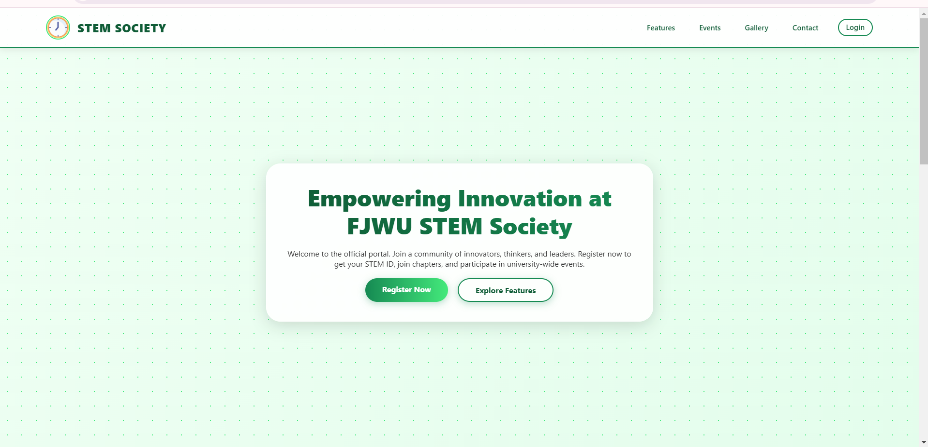

Admin dashboard:

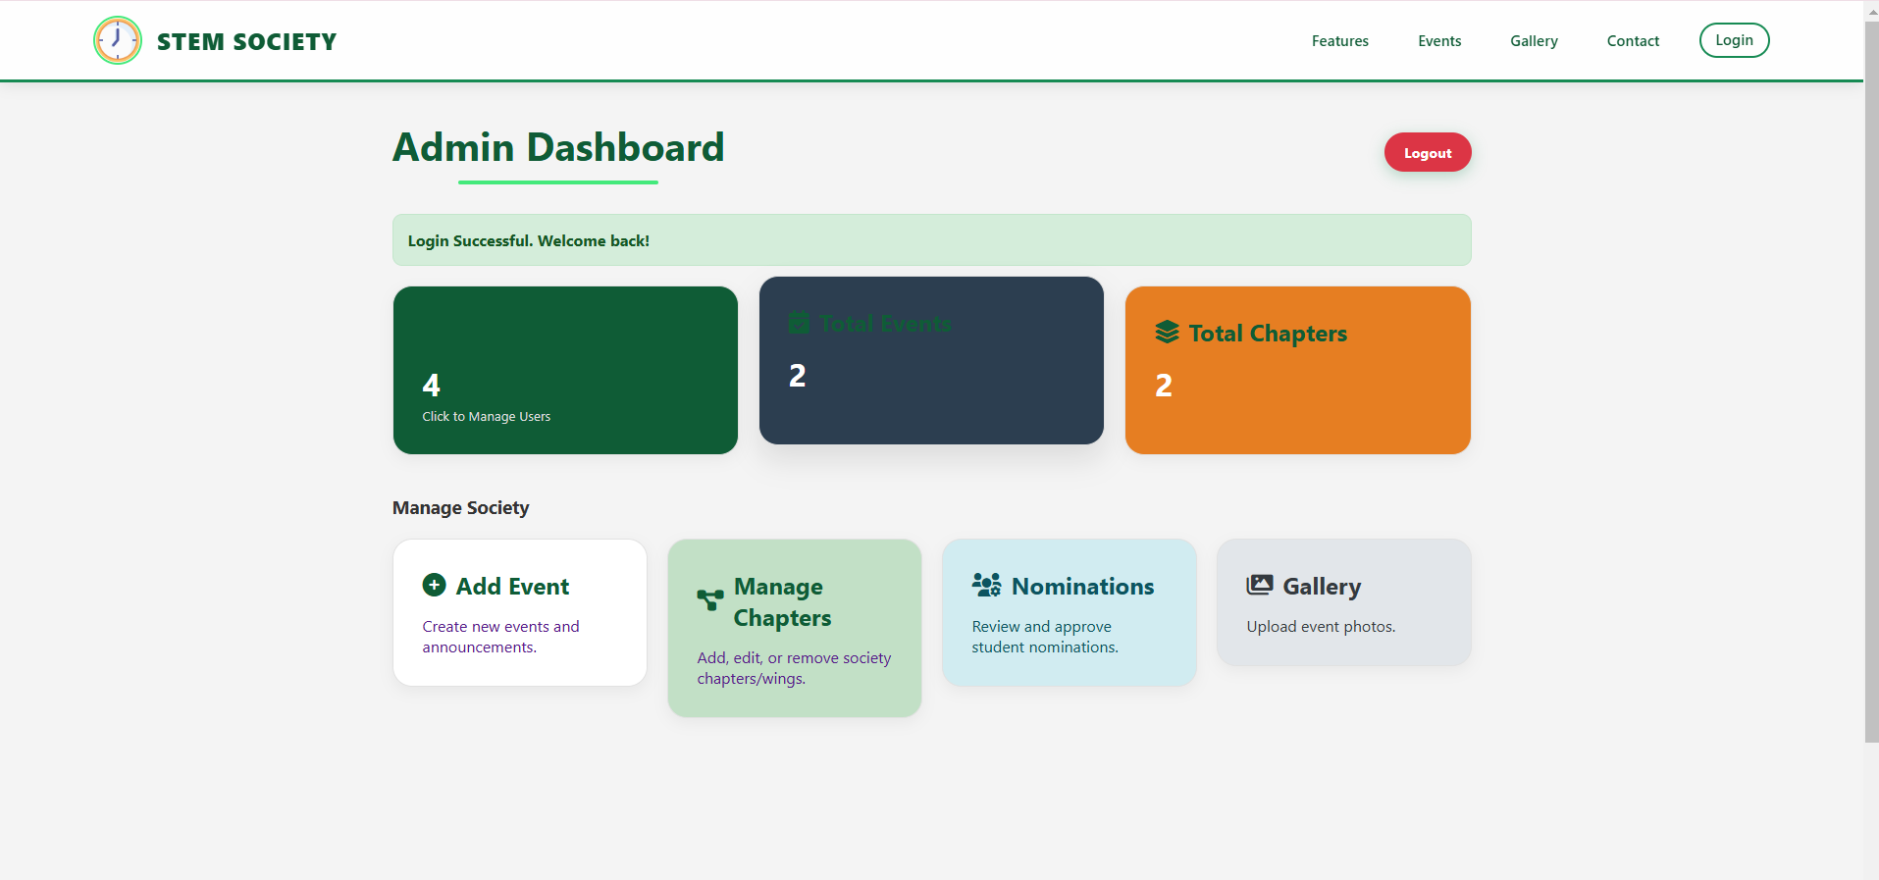

Event:

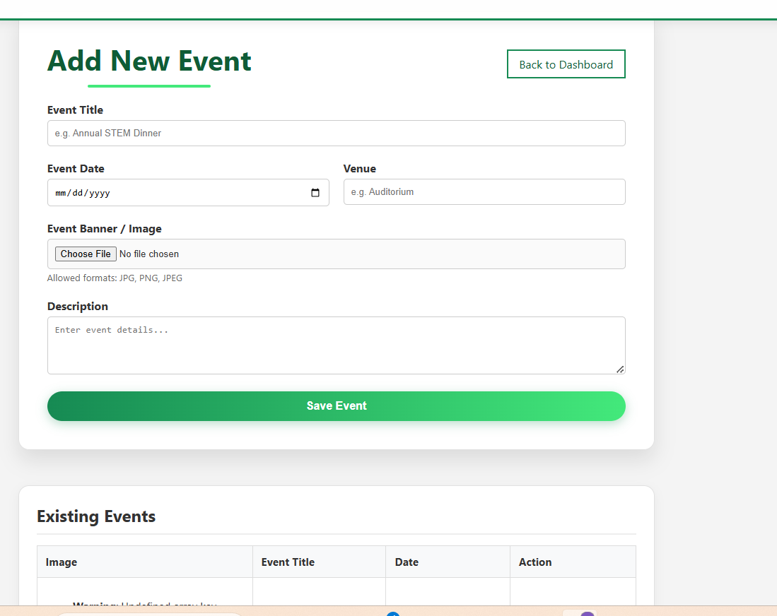

8. Conclusion
The FJWU STEM Society Portal successfully transforms a manual, paper-based system into a fully digital, automated, and secure platform. It addresses all the core problems defined in the problem statement by centralizing data, automating ID generation, and providing distinct, feature-rich panels for students and administrators. The inclusion of features like "Remember Me" cookies and detailed profile management ensures a high-quality user experience.

